**Experiment 4**

**Answer Sheet**

|  |  |  |
| --- | --- | --- |
| Name: | Sec. | B.N. |

Q1: Count Sequence is 0000 🡪 0001 🡪 0010 🡪 0011 🡪 0100 🡪 0101 🡪 0110 🡪 0111 🡪 1000 🡪 1001 🡪 1010 🡪 1011 🡪 1100 🡪 1101 🡪 1110 🡪 1111.

The Counter is modulo – 16.

Q2 (Draw the timing for N +1 pulses where N is the sequence length obtained in step Q1 :

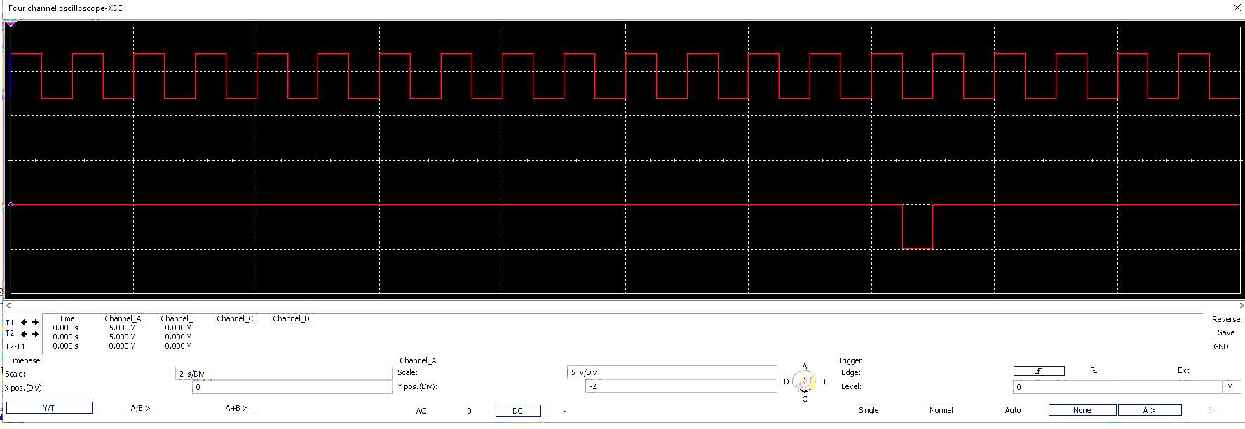

Q3: The circuit shown in fig. 2 is modulo-8 , Why?

Because it counts from 0 to 7, then the carry changes from 1 to 0, and repeats again.

Note: at the first, this design of counter is forced to count from 0 to 15 before it works as a modulo-8 counter.

Q4 (Draw the timing for N +1 pulses where N is the sequence length obtained in step 6 :

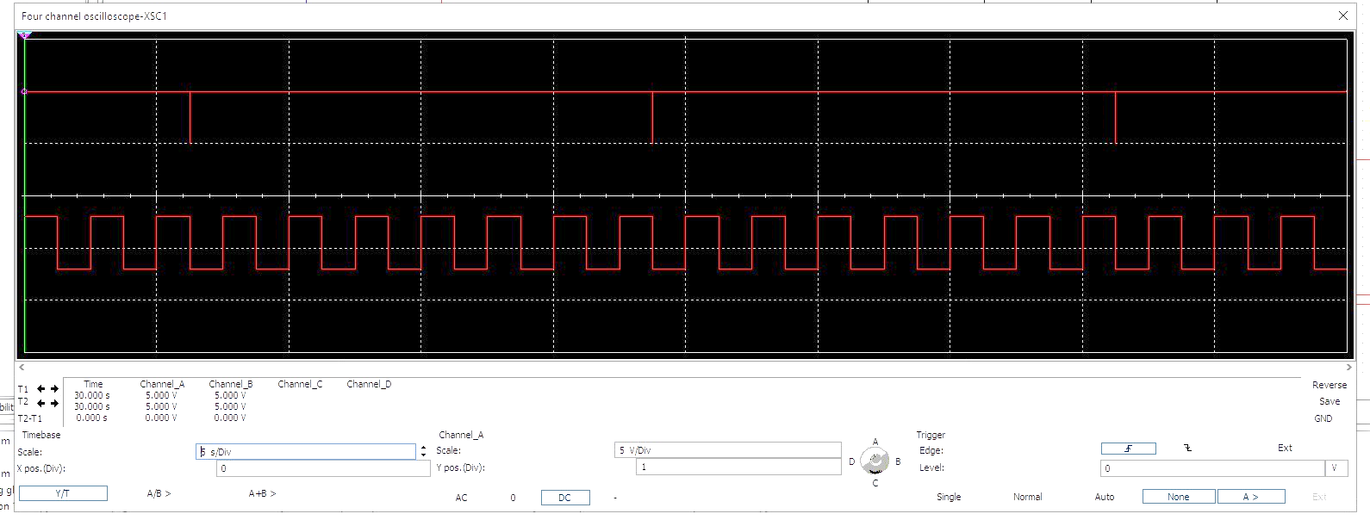

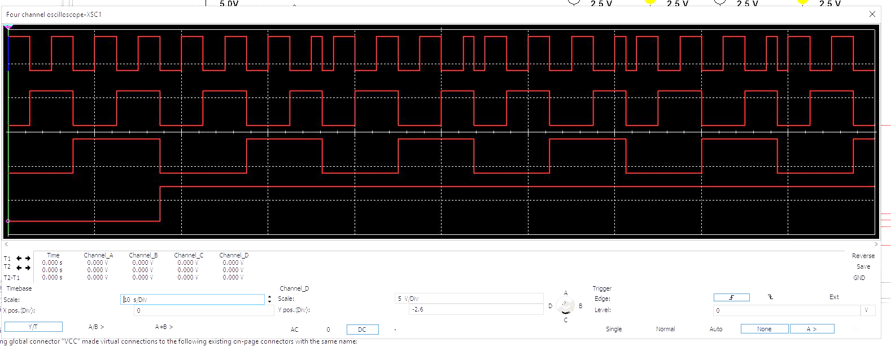

Comment on your observations

From observation it shows that is works as counter with modulo-8.

Steps 12 :

Q5 : Comment on your observation by stating the function of S1 and S2

S1 is responsible for loading data and shifting it.

S2 is responsible for enabling the clock.

Q6: Draw the timing for clock , QH of IC 74165 and SH/LD' for 7 clock pulses

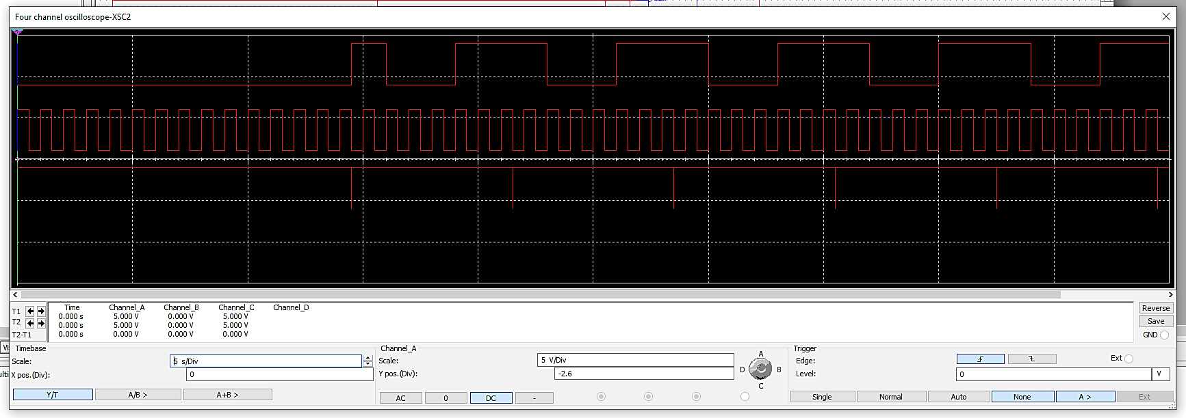

Comments:

Carry is connected to the inversed load, then when carry falls to zero, data is loaded again and then it is converted from parallel to serial.

Q7 : Draw the displayed waveforms ?. What is the relation between the displayed waveforms?

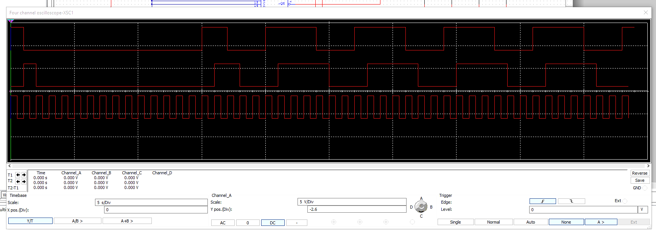

Comments: serial output is converted to parallel output through the S/P converter as it is loaded

Q8 : What is the relation between A,B,C,D,E,F,G,H inputs of IC 74165 and QA,QB,QC,QD,QE,QF,QG,QH outputs of IC 74164, show using the simulation?

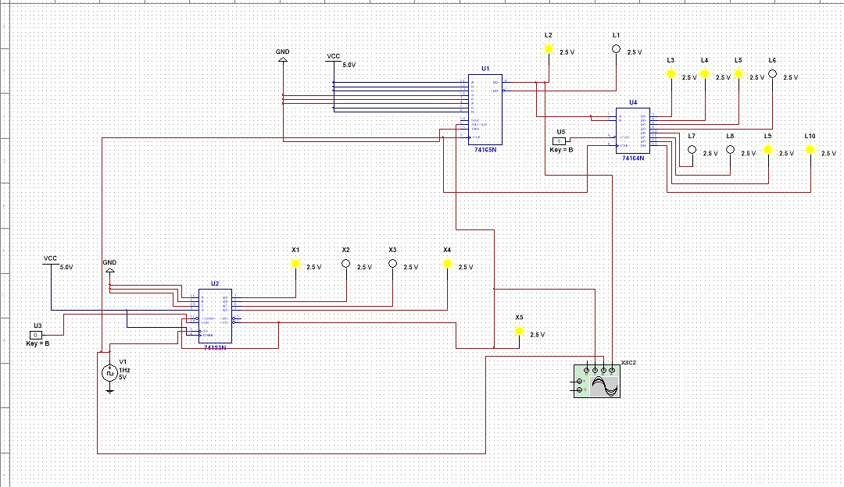

From the figure above, we observe that: QA = A,

QB = B,

QC = C,

QD = D,

QE = E,

QF = F,

QG = G,

QH = H.

**Part 2: ALU**

Adding 7 and 4

Output of the ALU………………………………………………..

Output carry…………………………………………………..…..

Your Simulation Graph

Adding 8 and 11

Output of the ALU………………………………………………..

Output carry…………………………………………………..…..

Your Simulation Graph

Subtracting 4 from 7

Output of the ALU………………………………………………..

Output carry…………………………………………………..…..

Your Simulation Graph

Subtracting 11 from 8

Output of the ALU………………………………………………..

Output carry…………………………………………………..…..

Your Simulation Graph

Verify the AND operation

Your Simulation Graph

Verify the OR operation

Your Simulation Graph

Verify the XOR operation

Your Simulation Graph

*Show how you can use replicates of your components to perform 8-bit addition/subtraction.*